Brand culture et développement des marques
Cours 1
Notoriété (capital de la marque) = brand equity
Swot / Opportunité-> peu de conçu
Force-> technique que seule la marque possède
1 brand value
  - Value création
Visual Identity= logo
Definition de brand: brand culture is the set of shared values, beliefs, behaviors(comportment) and symbols that shape how a brand is created, expressed, and experienced by all its stakeholders both inside the organization (employees, leadership) and outside (costumers, partners, communities)
It’s the personality of brand, reflected across:
- what the brand stands for (vision purpose, values)
- How its acts (costumer interaction, employee behaviors, business decisions)
- How it communicates (tones, storytelling, symbolism)
- How it is perceived (reputation, association, customer experience)
3 composantes d’une strategies de marque:
- Vision statement (de la boite)
- Mission statement
- Values statement

ex: brand culture Google?
Innovation and openness, expressed in its playful tone, internal work culture and products design
Ex Harley-Davidson (moto)
Freedom and rebellion, reinforced through its biker community and lifestyles positioning
Brand is value creation
In today’s competitive marketplace, brands have evolved far beyond simple logos and slogans
They represent value creation engines that drive business success influence consumer behaviors and shape cultural meaning
Schema producer
Wholesaler-> grosiste Retailer->detaillant
1 Manufacturers, sources of brand value
- Product Quality & Innovation: delivering superior performance or innovation builds trust and loyalty.
- Brand Equity & Recognition: the strength of their brand name translates into customer preference and pricing power.
- Heritage & Storytelling: long-standing history or strong brand narratives create authenticity.
- Marketing Investment: brand-building campaigns, endorsements (paraignage), and sponsoring reinforce brand presence.
- Intellectual Property (IP): trademarks (marque deposer), patents (brevet) and design rights protection

Ex apple manufacturer:
Creates value through product design, software integration and innovation (iPhone, mac)
Its powerful brand equity allows apple to command premium pricing and expand into services (appl music, iCloud)
La promesse un aliment sain
La prevue un expert de la dietetqiue plus la composition deailler du rpoduit
Le benfice le consomateur ma,ge sain et il le sait
Le ton le ton de l’expert, du conseiller

Tesla case study
Manufacturer, Distributor, Retailers et consumers
Through their website, Tesla shares about its intern politics. In what concerns Tesla’s manufacturing, the company started its manufacturing program in 2012 with their Model S rolled off the assembly line at their factory in Fremont, California. Today, they have the capacity to manufacture more than a million vehicles every year, in addition to energy products, battery cells and more. So, manufacturers are Tesla’s factories in the USA, Germany and China.
About their distributors, the company is able to be sold worldwide. Indeed, their products are available in proper Tesla concessions or in reseller stores all around the world. However, some laws and local policies are going against Tesla distribution program, as an example, the Cybertruck is forbidden to sale in the European Union due to security issues.
In what concerns retailers, Tesla does not rely on independent retailers or dealers. That means that Their stores as much as the Tesla service centers handle the selling and the testing of vehicles while handling maintenance and technical support.
Finally, Tesla’s end consumers include individual consumers, businesses, governments and institutions.
In a nutshell, the company pretty much handles the entirety of their supply chain, from the manufacturing to the consumers.

1. Manufacturers (Tesla itself)
Role: Create and grow the brand promise.
- Tesla builds electric cars that are modern, fast, and good for the planet.
- The brand promise is about innovation, sustainability, and a better future.
- Tesla keeps this promise by making its own batteries and new technology.

2. Distributors (Tesla’s direct system)
Role: Make sure the brand is available and trusted.
- Tesla sells cars directly on its website and in its own stores — not through car dealers.
- This helps Tesla control prices and the customer experience.
- Tesla’s service centers and Supercharger stations make the brand reliable and easy to use.

3. Retailers (Tesla Stores)
Role: Shape the buying experience and make the brand more desirable.
- Tesla Stores are modern and simple, made to let people see, touch, and test the cars.
- The goal is to create excitement, not pressure to buy.
- Consumer experience
- GRC= CRM (consumer relation manager)

4. Consumers (Tesla owners and fans)
Role: Support and spread the brand.
- Tesla owners often become fans and talk about the brand online.
- They share their experiences and help other people learn about Tesla.
- This makes the brand stronger and more popular.
Manufacturer: builds brand equity through innovation
Distributors tesla bypasses traditional distributor whit direct to consumer dtc channels reinforcing exclusivity
Retailers: tesla retail stores (experience-focused) elevate the premium brand perception
Consumer Act as brand evangelist, sharing experience online, strengthening the community and adding credibility
Advocacy de la marque
Association; distributing weel-known barands enhances their credibility
Reliatbely et trist: delivering brands to market builds repitation with both retailers and manufacturers
Exclusivity distrib:
Market coverage : The ability to make a brand available across countries adds value
Shelf Space (espace presentoir) & Visibility: premium placement in-store or online boosts brand
Customer Experience: a retailer’s ambiance, service quality and digital ux elevate the perceived value of brands they carry
Private Labels (marque de distributeur) & Co-Branding: retailers create their own brand value ( e.g, Walmart’s great value, amazon basics)
Consumer Trust & Loyalty Programs: strong retailer brands amplify the brands they sell
Channel Control: exclusive launches or collaborations enhance desirability
Scarcity
Perceived Quality & Status: the brands image (luxury, eco-friendly, affordable) drives personal identity expression
Emotional Connection: stories, values, and social causes resonate and build loyalty
Word of Mouth & Social Proof: positive reviews, social media post and influencer advocacy amplify brand equity
Community & Belonging: some brands foster tribes (Harley-Davidson riders, apple users)
Price Sensitivity & Loyalty:

Manufacturers: Create and nurture the brand
promise.
Distributors: Ensure brand availability and credibility
in the supply chain.
Retailers: Shape the consumer’s buying experience
and amplify brand desirability.
Consumers: Validate, reinforce, and extend the
brand through adoption and advocacy.
Apple évolue dans le secteur de la technologie. La marque incarne l’innovation, le design, la créativité et la simplicité. Les clients perçoivent Apple comme un symbole de modernité et de statut, et apprécient une expérience intuitive et premium.

Nike, dans le secteur du sport et de l’habillement, véhicule des valeurs de performance, de dépassement de soi et de motivation, illustrées par son slogan “Just Do It”. Les consommateurs ressentent une confiance en eux et un sentiment d’appartenance à une communauté active et gagnante.

Patagonia appartient au secteur de l’outdoor et de l’habillement. La marque se distingue par son engagement écologique et sa responsabilité sociale. Les clients interprètent Patagonia comme une marque éthique, et leur expérience traduit un choix de consommation responsable et durable.

Starbucks, dans le domaine de la restauration et des boissons, associe sa marque à des notions de communauté, de confort et de personnalisation. Les clients perçoivent Starbucks comme un “troisième lieu” entre le domicile et le travail, offrant une expérience chaleureuse et personnelle.

Lego appartient au secteur des jeux et de l’éducation. Son sens de marque repose sur la créativité, l’apprentissage par le jeu et l’imagination. Les consommateurs vivent une expérience ludique et éducative, mêlant plaisir, imagination et nostalgie.

L’Oréal, dans le secteur de la beauté et des cosmétiques, met en avant des valeurs de confiance en soi, d’inclusivité et de glamour, portées par le slogan “Parce que vous le valez bien”. Les clients associent la marque à l’estime de soi et à l’expression personnelle, tout en profitant d’une forme de luxe accessible.

Cours 3-4 ( 13 novembre)

2. THE BRAND LIFE CYCLE

- INTRODUCTION: Build awareness and identity (e.g., Tesla early years).
- GROWTH: Expand market share and loyalty (e.g., Apple iPhone adoption phase).
- MATURITY: Maintain differentiation and emotional engagement (e.g., Coca-Cola).
- DECLINE / RENEWAL: Rebrand or reposition to regain relevance (e.g., Burberry).
Each stage demands tailored communication, investment, and innovation strategy.NAVIGATING LIFE CYCLE CHALLENGES
INTRODUCTION
introductions require clear value propositions,
target audience identification, and marketing
campaigns. Research shows 95% of new products
fail due to poor brand positioning and market
misalignment.
GROWTH
During growth phases, brands must balance
expansion with consistency. KPIs include brand
awareness, consideraQon rates, and customer
acquisiQon costs.
MATURITY
Mature brands focus on loyalty retention and
profitability optimization. Strategies include
premium positioning, brand extensions, and
customer lifetime value maximization.Ø BCG matrix assumes that profitability and market share are highly related.
Ø A useful approach for making business decisions.
Ø An analysis on products according to growth and relative market share.

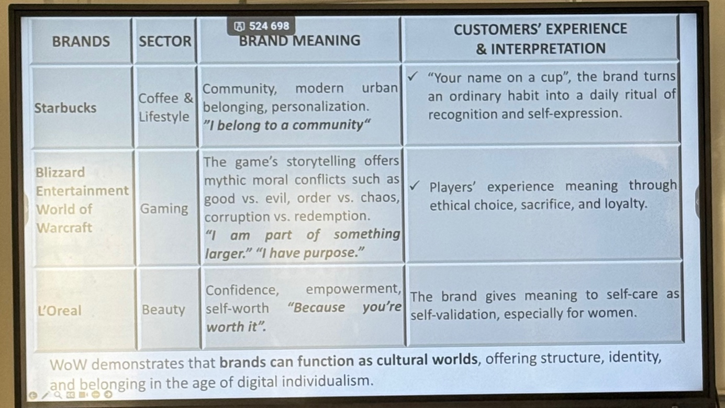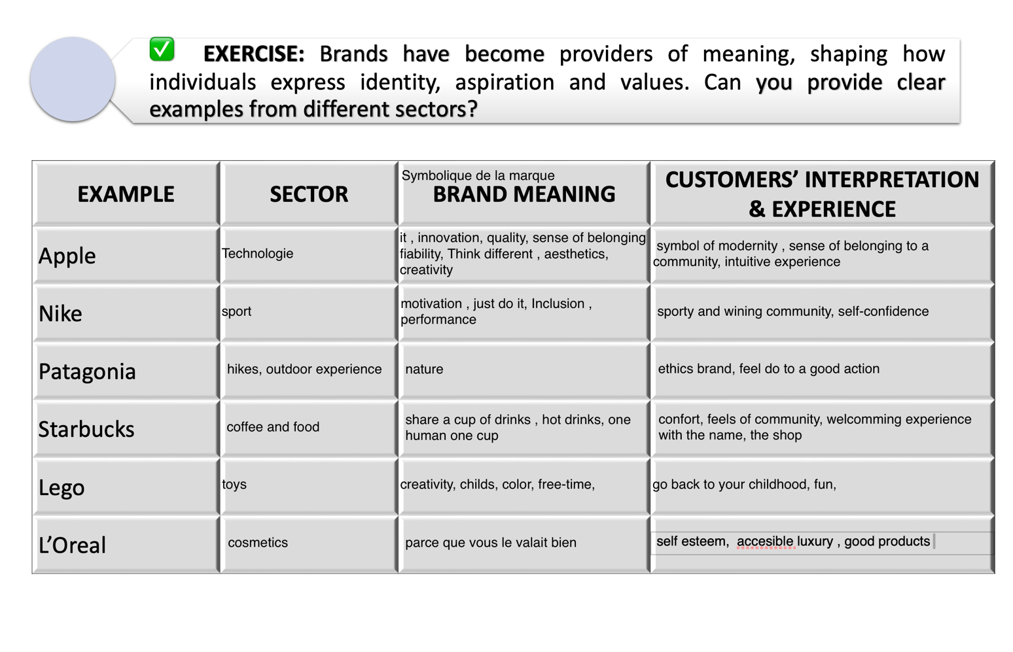
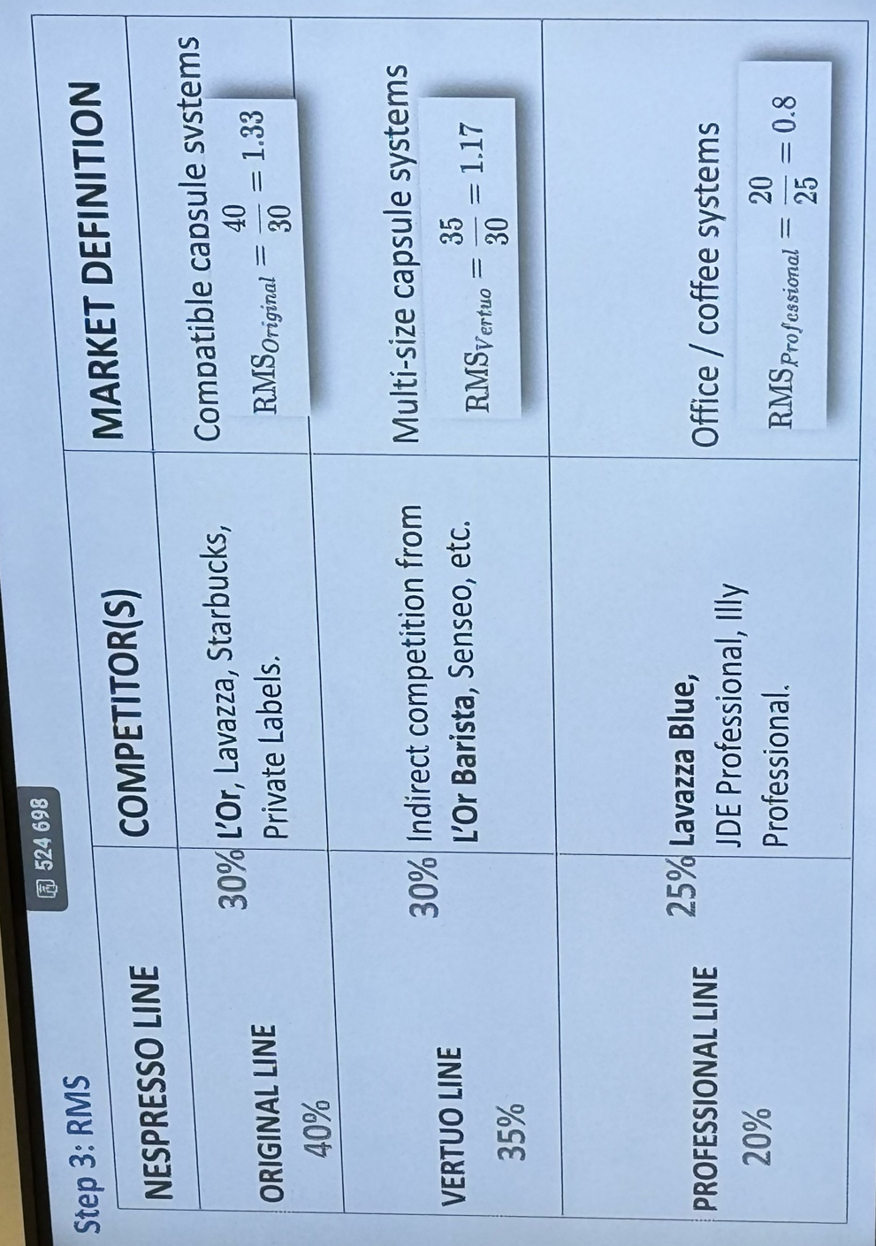

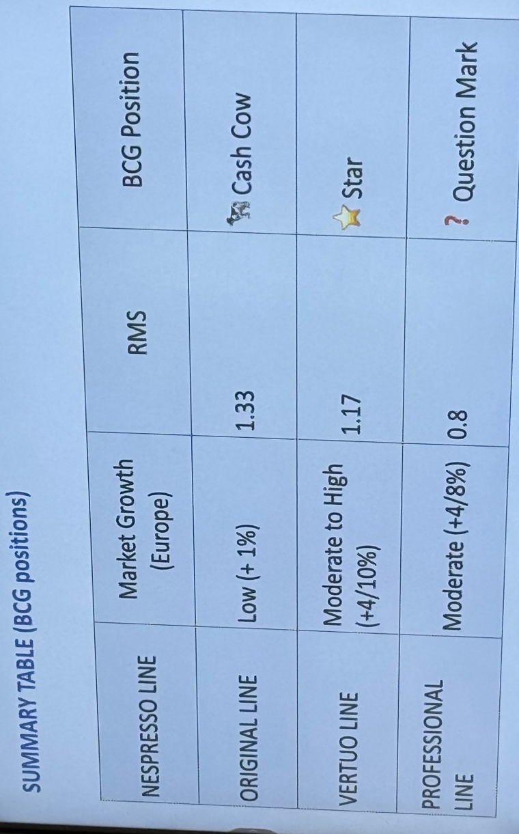

Plus de 1 en rms : vous etes un market leader donc star ou cash cow
Egale a 1 equal to top competor donc competitive parity
Moins de 1 market follower donc question mark ou dog

Step 4: strategies recommendation
1 milk cash cow (original line)( invest selectively!)
Objective maintain profitability in the mature espresso capsule segment
Actions: focus on customer retention via loyalty programs (Nespresso club, sustainability rewards)
Emphasize recycling and refillable capsul initiatives to protext brand equity and meet eu sustaninblity regulations
Optimize operational efficeny in supply chain and prioritize innovation only in flavors, seasonal offerings, and packaging

- invest in stars (vertuo line) <- invest to grow
objective: strengthen position in its heigh growth segment
actions: expand vertuo system distribution across Europe, especially in emergency coffee markets ( eg eastern Europe)
increase marketing and awareness around crema qualitu and capsuyl innovation
use personalization and digital platfomrs (app integration, su-bscritpion) to lock in custumers and to counteract l’or barista through exclusibve partenership and limited editioons blends

- reassess b2b (professional)<- harvest profits
objective: boost in offices and hospitality channels
action: offer customized subscription packages for small offices and co-working spaces
strengthen partenership (hotel resto, café) with sustainable and premium
explore cross selling ( truc pour mettre le café qql part ) with Nestlé professional portfolio for synergy and scale

3. brand architecture

Defines how brands, sub-brands, and products relate within a portfolio.

TYPES OF BRAND ARCHITECTURE:

- Monolithic (Branded House): One identity (e.g., Virgin).

- Endorsed Brands: Sub-brands backed by master brand (e.g., Courtyard by
- Marriott).

- Freestanding (House of Brands): Independent brands (e.g., Procter & Gamble).

- Hybrid: Combination (e.g., Alphabet/Google).
- Align structure with diversification, risk and clarity.

Porsche can sell branded clothing, gloves, sunglasses, luggage, paper clips (in the shape of a Porsche), and baby products.

4. brand portfolio management

Managing multiple brands to maximize synergy, coverage, and profitability.

- CHALLENGES: defining brand roles, managing resources, avoiding
cannibaliza9on.

- PORTFOLIO OPTIMIZATION: Audit → Map → Ra9onalize → Leverage.
Example: Unilever aligns 400+ brands under unified sustainability goals.

✅ PRAGMATIC INSIGHT:
Balance focus (eﬃciency) with breadth (market reach).

Open Happiness, sharing moments, collective
memory.
Slogans like “Have a Coke and a Smile.” Selling a
moment of joy.
- Bright red color psychology (associated with energy
and positivity). Emotional music and “feel-good”
storytelling.
CUSTOMER’S
INTERPRETATION

Reflects stability, rituals,
emotional comfort through
iconic advertising.
- I celebrate joy and
connection.
- Coke brings people together
Reflects identity, style and

For the Cultural meaning Coca-Cola shows moments of sharing, surraoundid by warm and friendly people. There are slogans like “Have a Coke and smile.”or Things go better with Coke It doesn’t sell a product, it sells a moment. In the ads, there is always emotional and joyful music, which also represents social sharing.

For the Customer interpretation Coca-Cola reflects emotional comfort thanks to its strong reputation. It’s shows joy and social connection. and brings people together like friends and families.

